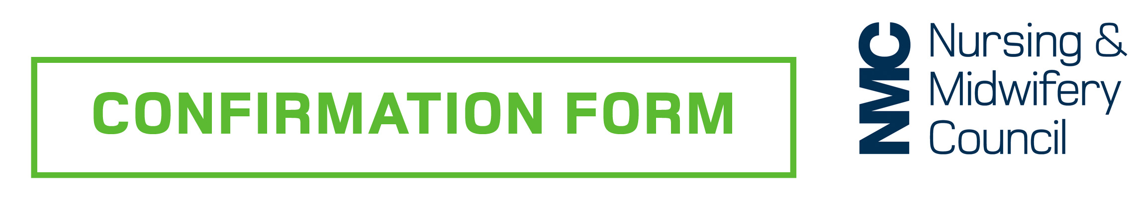

You must use this form to record your confirmation.

To be completed by the nurse, midwife or nursing associate:

Name:
NMC Pin:
Date of last renewal of registration or joined the register:

I have received confirmation from (select applicable):
A line manager who is also an NMC-registered nurse, midwife or nursing associate
A line manager who is not an NMC-registered nurse, midwife or nursing associate
Another NMC-registered nurse, midwife or nursing associate
A regulated healthcare professional
An overseas regulated healthcare professional
Other professional in accordance with the NMC’s online confirmation tool

To be completed by the confirmer:

Name:
Job title:
Email address:
Professional address including postcode:
Contact number:
Date of confirmation discussion:

If you are an NMC-registered nurse, midwife or nursing associate please provide:
NMC Pin:

If you are a regulated healthcare professional please provide:
Profession:
Registration number for regulatory body:

If you are an overseas regulated healthcare professional please provide:
Country:
Profession:
Registration number for regulatory body:

If you are another professional please provide:
Profession:
Registration number for regulatory body (if relevant):

Confirmation checklist of revalidation requirements

Practice hours

You have seen written evidence that satisfies you that the nurse, midwife or nursing associate has practised the minimum number of hours required for their registration

Continuing professional development

You have seen written evidence that satisfies you that the nurse, midwife or nursing associate has undertaken 35 hours of CPD relevant to their practice as a nurse, midwife or nursing associate

You have seen evidence that at least 20 of the 35 hours include participatory learning relevant to their practice as a nurse, midwife or nursing associate.

You have seen accurate records of the CPD undertaken.

Practice-related feedback

You are satisfied that the nurse, midwife or nursing associate has obtained five pieces of practice-related feedback.

Written reflective accounts

You have seen five written reflective accounts on the nurse, midwife or nursing associate’s CPD and/or practice-related feedback and/or an event or experience in their practice and how this relates to the Code, recorded on the NMC form.

Reflective discussion

You have seen a completed and signed form showing that the nurse, midwife or nursing associate has discussed their reflective accounts with another NMC-registered individual(or you are an NMC-registered individual who has discussed these with the nurse, midwife or nursing associate yourself).

I confirm that I have read Information for confirmers, and that the above named NMC-registered nurse, midwife or nursing associate has demonstrated to me that they have met all of the NMC revalidation requirements listed above during the three years since their registration was last renewed or they joined the register as set out in Information for confirmers.
I agree to be contacted by the NMC to provide further information if necessary for verification purposes. I am aware that if I do not respond to a request for verification information I may put the nurse, midwife or nursing associate’s registration application at risk.
Signature:
Date:

