
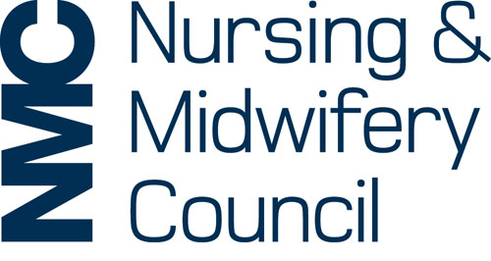
You must use this form to record your reflective discussion with another NMC-registered nurse, midwife or nursing associate about your five written reflective accounts. During your discussion you should not discuss patients, service users, colleagues in a way that could identify them unless they expressly agree, and in the discussion summary section below make sure you do not include any information that might identify an individual. Please refer to the section on non-identifiable information in How to revalidate with the NMC for further information. For more information about reflective discussion, please refer to our guidance sheet on reflective practice for revalidation.
.

To be completed by the nurse, midwife or nursing associate:
Name:
NMC Pin:

To be completed by the nurse, midwife or nursing associate with whom you had the discussion:
Name:
NMC Pin:
Email address:
Professional address including postcode:
Contact number:
Date of discussion:
Short summary of discussion:

I have discussed five written reflective accounts with the named nurse, midwife or nursing associate as part of a reflective discussion.  I agree to be contacted by the NMC to provide further information if necessary for verification purposes. | Signature:
 | Date:

